Contents
1 Introduction 2
1.1 Purpose and Scope 2
2 Overview 2
3 Service support sub-project 3
3.1 SERVICE CLIENT SUPPORT - CREATING THE CLIENT CLASS…………..…………………...….3
3.2 SERVICE IMPLEMENTATION SUPPORT - CREATING THE SERVICE CLASS…..………………3
4 HARNESS SUB_PROJECT 4
5 SERVER APPLICATION SUB_PROJECT 5
5.1 CREATING THE SERVER CLASS……………….…………………………………………………...….5
5.2 MINIMAL SERVER APPLICATION…………….……………….……...…………………………………5
5.2.1 SESSION CLASS IN THE SERVER APPLICATION …….…………………………………...….5
5.2.2 UI APPLICATION CLASSES IN THE SERVER APPLICATION…………………………………5
6 Implementation Considerations 6
6.1 SECURITY…………………...………..…………………………………………………………………….3
6.2 UIDS……………………….…………………………………………………………………………………3
8 Testing 7
Appendix A : SUMMARY OF CLASS HIERARCHY 8

Introduction

Server Applications have been used in Symbian OS since the introduction of Platform Security in v9.0. An introduction to Server Applications can be found in the Symbian OS Library.

This document is a short accompaniment to the Minimal Server Application example. This application example has been written to demonstrate how to use the Server Application framework developed by Symbian.

Purpose and Scope
The purpose of this document is to provide a clear description of the Minimal Server Application example. It is intended to help Symbian developers implement more elaborate Server Applications. For further information on Server Applications see the Developer Library ( » Symbian OS guide » Application framework » Using Application Architecture - Server Apps » Server applications )

Overview
Three distinct areas can be identified in a Server Application: the client, the service support and the server application. The Server Application Framework is provided by the Symbian Apparc and Uikon components.

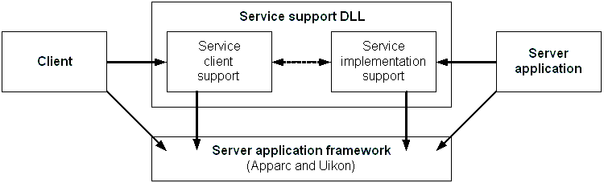

Therefore, the example application has been developed comprising three sub-projects:
1) A harness project which uses the Client API to generate a client request and trigger the server application
2) A service_support project consisting of Service Client Support and Service Implementation Support. Both client-side and server application-side support are built into a single DLL which encapsulates the IPC protocol between client and server.
3) A server_application project that provides the entry point into the server application. This sub-project consists of the Server class and of the actual Application.

A common header file, definitions.h, contains constant definitions required by all of the sub-projects. This project implements only one service and one service request (opcode) so the header file is simple.
const TUid KServiceType = { 0xE1111555 };
enum TServAppServRqst
{
EServAppServExample = RApaAppServiceBase::KServiceCmdBase
};

The Service Support DLL is described first as both Client and Server are dependant upon it.

Service Support sub-project
As mentioned before, the service_support sub-project consists of Service Client Support and Service Implementation Support. The Service Client Support is defined and implemented in files client_api.h and client_api.cpp, and the Service Implementation Support in files session.h and session.cpp.

Service Client support – Creating the client class
The RServAppService class (see client_api.h , client_api.cpp) was created for Service Client support. The class is derived from REikAppServiceBase (defined in eikserverapp.h) so that a new server application instance is started when a connection is made (through REikAppServiceBase::ConnectNewAppL()).
- RServAppService implements the client API. It needs to send a request for service to the server side. RServAppService::Send() performs in this example application using a SendReceive() call that sends a client message (contained in a descriptor) to the server.
TInt RServAppService::Send(const TDesC & aMessage)
{
return SendReceive(EServAppServExample,TIpcArgs(&aMessage));
}

- RServAppService overrides the pure virtual function RApaAppServiceBase::ServiceUid() to return the UID of the service the client has requested.
TUid RServAppService::ServiceUid() const
{
return KServiceType;
}

3.2 Service Implementation support – Creating the service class
The CServAppSession class (see session.h , session.cpp) provides the Service Implementation support (support for the sessions connected to the server). This class is derived from CApaAppServiceBase (defined in apaserverapp.h).
- The main purpose of this class is to override the pure virtual function CSession2::ServiceL() such that a call to the appropriate service support code is made for the service type requested by the client. CServAppSession::ServiceL() contains a switch() structure that uses the service opcode enumeration (defined in definitions.h) to execute the appropriate branch. If the requested service is unidentified the ServiceL() method of the base class is called.
void CServAppSession::ServiceL (const RMessage2& aMessage)
{
TInt ret = KErrNone;
switch(aMessage.Function())
{
case EServAppServExample:
HBufC* buf;
buf = HBufC::NewLC(aMessage.GetDesLength(0));
TPtr ptr (buf->Des());
ret = aMessage.Read(0,ptr);
Display(ptr);
CleanupStack::PopAndDestroy(buf);
break;
default:
CApaAppServiceBase::ServiceL(aMessage);
break;
}
aMessage.Complete(ret);
}

- The CServAppSession class does not implement the service but is, itself, an abstract base class from which the Server Application is derived. i.e. the Service Support DLL does not implement the service. In this minimal application, where only one service type is provided, the branch code corresponding to this service will extract the client message from the RMessage wrapping and pass it to a pure virtual function Display().
virtual void Display(const TDesC & aMessage) = 0;

Harness sub-project
The harness sub-project contains an E32Main() function (see main.cpp) that uses the client API to generate a client request which causes the Server Application to be started. No class declaration or instantiation takes place.
Note that the server application UID needs to be known.
const TUid KAppUid = { 0xE1111556 };

LOCAL_C void callExampleL()
{
RServAppService exampleSess;

_LIT(KHelloWorld,"Hello World!");

TBufC<12> exampleBuf(KHelloWorld);

exampleSess.ConnectNewAppL(KAppUid);
exampleSess.Send(exampleBuf);
exampleSess.Close();
}

Server application sub-project
The Server and the Minimal Application are the two main components of the server application sub-project.

5.1 Creating the Server class
The server class CServAppServer (see server.h , server.cpp) is derived from CEikAppServer class (defined in eikserverapp.h) so that a new server application can be instantiated when a new connection is made. Had it been derived directly from CApaAppServer it would be able to connect to an existing server application only.
Since CEikAppServer is derived from CApaAppServer, CServAppServer is required to override the virtual function CApaAppServer::CreateServiceL(). CServAppServer::CreateServiceL() identifies the type of service (as defined in definitions.h) that the client has requested and creates a session instance in the application side that implements it. In the case of an unidentified service type, the base class implementation of the method is called.

CApaAppServiceBase* CServAppServer::CreateServiceL(TUid aServiceType) const
{
if (aServiceType==KServiceType)
return new(ELeave) CMinimalSession();
else
return CEikAppServer::CreateServiceL(aServiceType);
}

5.2 Minimal server application
Following the pattern of the generic minimal UI application (the code of which can be found under examples\AppFramework\Apparc\Minimal\) the minimal server application contains an E32Main() function providing the entry point to a server application (in serv_app_minimal_main.cpp) separate from the UI application classes (see serv_app_minimal.h, serv_app_minimal.cpp). However a new session class, CMinimalSession, has been implemented together with the UI classes.

5.2.1 Session class in the server application
The main role of CMinimalSession is to implement the service the client has requested via the service support DLL. CMinimalSession is therefore derived from CServAppSession (defined in the service_support sub-project) and implements the pure virtual function CServAppSession::Display() to handle the client request. Our function simply displays the message passed by the client.

void CMinimalSession::Display(const TDesC & aMessage)
{
CEikonEnv::Static()->AlertWin(aMessage);
}

5.2.2 UI application classes in the server application
The four UI Application classes, CExampleApplication (application class), CExampleDocument (document class), CExampleAppUi (application UI class) and CExampleAppView (view class) are pretty much the same as those in the minimal UI application example. The modifications that have been made are described below:
- CEikApplication::NewAppServerL() has been overridden in the application class CExampleApplication to launch a new server application instance.
void CExampleApplication::NewAppServerL(CApaAppServer*& aAppServer)
{
aAppServer = new (ELeave) CServAppServer;
}

- CExampleAppView::Draw() has been altered so that it produces an empty view.
void CExampleAppView::Draw(const TRect& /*aRect*/) const
{
CWindowGc& gc = SystemGc();
gc.Clear();
}

Implementation Considerations

Security
One important aspect of server applications that is not addressed in our minimal application is that of security. Here is a brief outline of the security features available to server applications. For further details please see the Server Application Documentation in the Symbian OS Library.
On the client side RApaAppServiceBase has mechanisms to protect the client from a malicious server. A client can monitor the lifetime of a server application using CApaServerExitMonitor and MApaServerAppExitMonitor. These classes operate in conjunction with RApaAppServiceBase::NotifyServerExit() and RApaAppServiceBase::CancelNotifyServerExit()
On the server side a security policy can be applied to protect the server from malicious clients. CApaAppServer provides the virtual functions CreateServiceSecurityCheckL() and SecurityCheckL() which may be implemented in server implementations to check client capabilities on connection and on receipt of messages respectively.

UIDs
In this minimal server application example two different UIDs have been used: the Service UID (0xE1111555) and the Application UID (0xE1111556). The first one is the UID of the service that the client requests and the server services, whereas the second one is the UID of the application that the server application implements. Because these two UIDs play an important role in several components of this example application this section summarises their use.
The Service UID is used:
in the Service Support project
- as the UID3 value in service_support.mmp file

in the Harness project and in the Server Application project
- as the constant KServiceType in definitions.h that is used in RServAppService::ServiceUid() (client_api.cpp in harness project) and in CServAppServer::CreateServiceL() (server.cpp in server_application project).

The Application UID is used
in Harness project
- as the constant KAppUid, when calling RServAppService::ConnectNewAppL() in Harness project (main.cpp)

in Server Application project
- as the UID3 value in serv_app_minimal.mmp file
- as the UID3 value in register file serv_app_minimal_reg.rss
- as the constant KUidServAppMinimal in CExampleApplication::AppDllUid() (serv_app_minimal.cpp).

Testing
The Symbian OS build process describes how to build an application. All three sub-projects (harness, service_support, server_application) have to be built. The whole application should run by running the harness project.
The Server_App_minimal example builds three executables in the standard location (\epoc32\release\winscw\<build_variant> for CodeWarrior): harness.exe, service_support.dll and serv_app_minimal.exe. Either launch the harness.exe executable itself, or launch the emulator and then select the Server_App_Minimal application from the emulator's extras bar.
A message upon an empty view is the expected result. The serv_app_minimal.exe executable can be launched as well but it will just produce an empty view as there will be no client request.
Appendix A: Summary of Class Hierarchy
The class hierarchy regarding the classes that have been used in this application example can be summarised as follows.

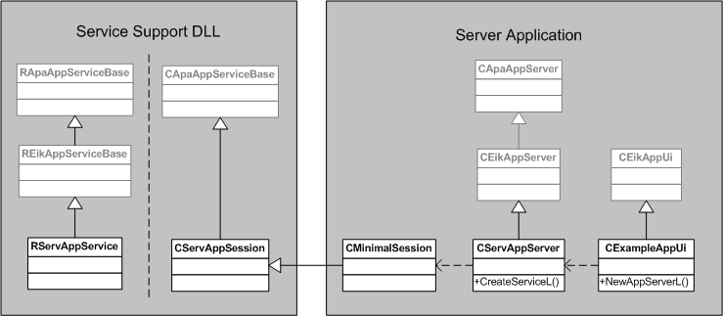

Service Support
RApaAppServiceBase → REikAppServiceBase → RServAppService
CApaAppServiceBase → CServAppSession

Server Application
CApaAppServer → CEikAppServer → CServAppServer
CApaAppServiceBase → CServAppSession → CMinimalSession
CApaApplication → CEikApplication → CExampleApplication
CEikDocument → CExampleDocument
CEikAppUi → CExampleAppUi
CCoeControl → CExampleAppView

Classes in bold letters are those that were implemented during the application development. Classes in blue letters are those that already exist in the Symbian OS.

The following information is given in order to help understanding the file and linking dependencies of the three sub-projects of the example application:
RApaAppServiceBase, CApaAppServer and CApaApplication classes are defined in apaserverapp.h and are linked against apparc.lib.
REikAppServiceBase, CEikAppServer and CEikApplication classes are defined in eikapp.h and are linked against eikcore.lib.

